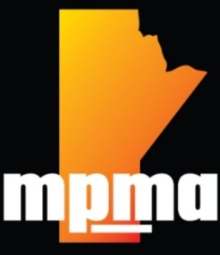

MPMA Annual Training

Conference Agenda

Friday, January 19, 2024
200 Kenny St.

10.00 am – 11:00 am | Registration and Meet and Greet
11:00 am – 11:15 am | MPMA Introduction - Taz Stuart
11:15 am – 12:00 pm | Exhibits Open | James Korosil – Wildlife Control Presentation
 |  | Sponsor/Supplier Presentations/Discussions
1.00 pm – 1.45pm |  | Denise IIchyna - Pesticide Compliance and Enforcement Officer - Health Canada
1.45 pm – 230 pm |  | Julie Swanlund – Senior Public Health Inspector presentation on What PHI’s look for in locations for Pest Control
2.30 pm – 3.15 pm |  | Tyler Vandervis – Safety Coordinator - PMP Safety Presentation
 |  | Closing Comments/Questions

THANK YOU to our sponsors:

